Database Project

Tech Store



Instructor:

Muhammad Junaid Nazar

Submitted by

Daniyal Haider

{241847}

Abdul Moeed Raza Kazmi

{241920}

Department Of Computer Science

11-06-2025

Introduction:

This project presents the design and implementation of an online Tech Store, developed as a database-centric web application. It encompasses both frontend and backend components. The frontend is built using the .NET framework, while MySQL is used to manage the backend database. The two are integrated using C#.

The system is structured to support efficient and secure operations typical of an e-commerce platform. The database schema includes **10 distinct tables**, designed to manage core functionalities such as product listings, customer information, orders, payments, and inventory control.

ERD:

The ERD represents the logical relationships between the key entities in the system. It outlines how data is organized and interconnected, forming the foundation of the database design.

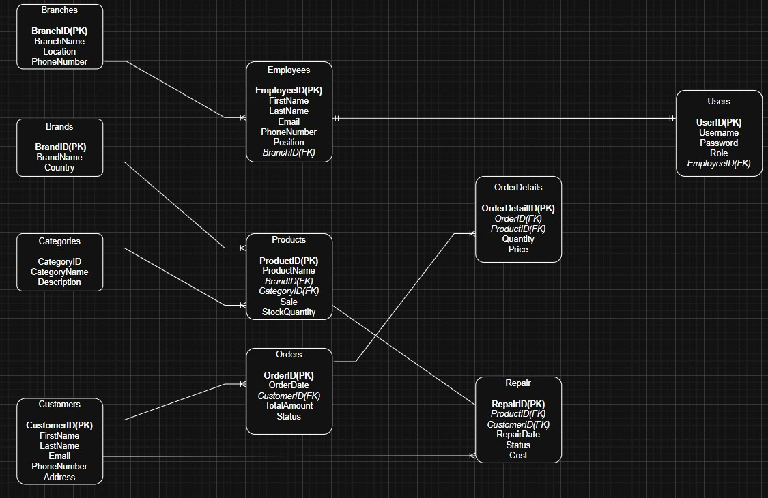

EERD:

The EERD builds upon the ERD by incorporating more complex modeling concepts such as generalization, specialization, and categorization. It captures additional constraints and attributes that are essential for advanced database management.

